|  |  |
| --- | --- |
|  | **E - ATHENAEUM**  **Technical Design Document** |
| |  |  |  |  | | --- | --- | --- | --- | |  | **Prepared By / Last Updated By** | **Reviewed By** | **Approved By** | | **Name** | 1. Balaji Ravindaran - (2128548)  2. Ritvik Gawri - (2126833)  3. Diyya Das - (2128347)  4. Yerragudi Pallavi - (2129498)  5. Akarshak Bose - (2127992) |  |  | | **Role** | 1. Pod Leader  2. Pod Member  3. Pod Member  4. Pod Member  5. Pod Member |  |  | | **Signature** |  |  |  | | **Date** | 20-06-2022 |  |  | |
|  |

**Table of Contents**

**1.0****Introduction 3**

**1.1****Purpose of this document 3**

**1.2****Project overview 3**

**2.0****Solution Summary 3**

**2.1****Scope 3**

**2.2****Assumptions** 4

**2.3****Dependencies** 4

**2.4****Risks** 4

**3.0****Schematic Diagram 5**

**3.1 Administrator Sequence Diagram 5**

**3.2 User Sequence Diagram 6**

**3.3 User Case Diagram 7**

**4.0****System Design** 7

**4.1****Proposed design** 7

**4.2****Component inventory** 7

**5.0****Database Design** 9

**5.1****Data Model** 9

**5.2****Tables Structure** 10

**6.0****Appendices** 12

**6.1****Glossary** 12

**7.0****Terms & Conditions** 12

**8.0****Change Log** 13

# Introduction

## Purpose of this document

The purpose of this document is to document the technical design, component details, and Database design. This will also capture the scope, assumptions, risk, and dependencies of this project.

## Project overview

E-Athenaeum is an online Library Management system that simplifies the process of book administration and management electronically according to the person's needs and requirements. The project compiles the information about the books present in the library, their authors, the members of the library to whom the books are issued, etc.

The main motive of the project is to computerize and automate the various operations and this would help in increasing the accessibility of the users. The use of technology in this management system would make this complex task to be easy and also be performed faster. The computerization of the system would reduce the workload and decrease manual labor.

The project includes features/facilities for the admin to monitor the whole system. It also provides the facility where users can login and manage their accounts to see the books present in the database inventory and the books issued. The admin after logging into his/her account can efficiently manage the e-library with features like author management, publisher management, etc.

Overall, the project would aid in keeping track of all the books available in the library and solve the tedious task of continuously checking and keeping track of all the books issued and returned. The project is designed to assist the students as well as the staff to maintain the library easily without much human effort.

# Solution Summary

## Scope

The E-Athenaeum is a management system that is used to manage and operate a large quantity of data that is generated from the libraries. The scope of this project consists of the successful creation of a fully developed library management system using ASP.net and MS SQL server in order to assist the staff as well as the user to reduce the efforts that are generally spent on this tedious task of management. It would increase efficiency and productivity through computerization.

The project includes many features that are generally not available in a traditional library management system. The project consists of a web application that has several functionalities such as user login and profile maintenance, admin login with several unique functionalities such as maintaining different data about authors, having access to other user accounts, and accounting for users under due. Along with this, a facility where users can see a list of books issued and view the complete book inventory along with many privileges for the admin, etc.,

## Assumptions

Assumptions for this project being,

* Creating a member signup page where new users can signup for library access.
* Creating a member login page where existing users can login.
* Creating a page where we can view the available books.
* Creating a page where admins can login.
* Creating pages like Author/ Publisher and Inventory management to manage (Add/Update/Delete) their data.
* Creating a page to manage the issuing and return process of the books.

## Dependencies

Technology used -

* ASP.NET with C# programming
* MS-SQL Database
* Bootstrap

Software Used -

* Visual Studio 2019
* SQL Server Management Studio (SSMS)
* Browser (Chrome, Edge, etc.)

## Risks

Considering real-world scenarios, risks for this project being several factors such as

* Broken Authentication and Session Management.
* Security Misconfiguration.
* Unvalidated Redirects and Forwards.
* Connection Failures.
* Vulnerabilities to SQL injections

.

# Schematic Diagram

## Administrator Sequence Diagram

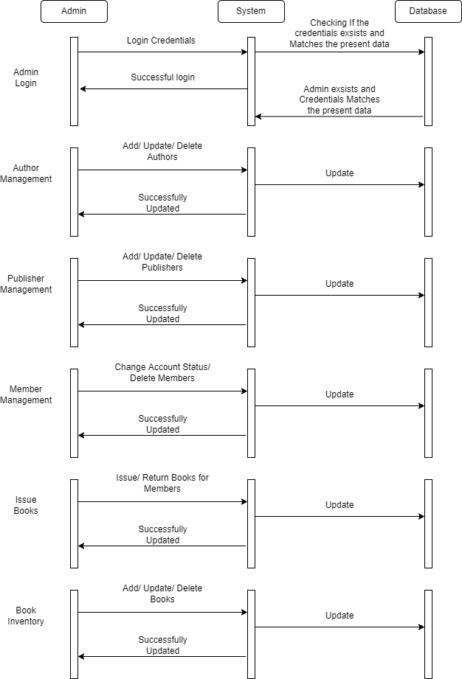

## User Sequence Diagram

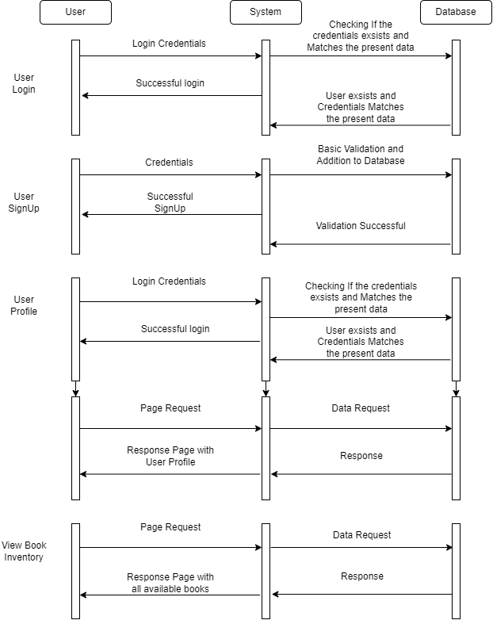

## User Case Diagram

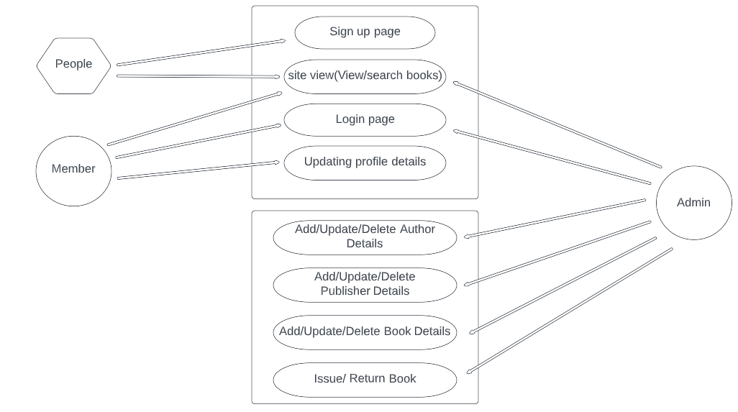

# System Design

## Proposed design

The project is planned to use the ASP.net web application framework as the core working environment for producing dynamic web pages with different functionalities.

Where the data created during the user interactions in the front-end pages such as creating a new account etc, are stored in a back-end SQL Server database. Since there are different functionalities to this project there are to be different tables created under a single database, where each table carries its own data, for example, a dedicated table only contributing to saving the data about authors, and another table only contributing to saving the data about publishers, etc.

The User Interface (UI) is proposed to be designed with the help of bootstrap considering the aesthetics and responsiveness of the dynamic pages, One particular page where the available books can be viewed in a tabular format is considered to be designed with the help of “datatables” which is a plugin for jQuery dedicated to creating responsive tabular content in web pages.

## Component inventory

Components for this project are

Technologies,

* ASP.net framework for creating dynamic web pages with C#.
  + Static Home page: Home page for the web application.
  + Member registration: For the user to register as a member and use the facilities.
  + Member login: After registering successfully, members can login into the system.
  + Member profile page: Members can manage their profile, and Update their details
  + Book issue page: An admin can monitor and perform issue/return of any particular available book/books.
  + Admin login: Admin login page for the admins to enter the system and use the facilities.
  + Author Management Page: Consists of the list of authors, only the admins can access and perform CRUD operations.
  + Publisher Management Page: Consists of the list of publishers, only the admins can access and perform CRUD operations.
  + Member Management page: For the admin, delete/ update the profile status of the members.
  + Book inventory page: For admins, to perform CRUD operations and maintain the books present in the library.
  + View Books page: For the users to browse through the available books in the inventory.
* Bootstrap for responsiveness and aesthetics of web pages.
* SQL server for storing the data created by different functionalities, under the following tables,
  + author_tbl (For managing different authors).
  + publisher_tbl (For managing different publishers).
  + member_tbl (For managing different members)
  + admin_tbl (For managing different admins).
  + book_tbl (For managing different books).
  + book_issue_tbl (For managing Issue/Due dates of the users).

Softwares,

* Visual Studio 2019 for programming ASP.net web pages and hosting them.
* MSSQL Express 2019 for hosting the database on the local machine.
* SQL Server Management Studio (SSMS) for Visualizing the database.
* Browser (Chrome, Edge, etc.) for running/testing the web pages.

# Database Design

## Data Model

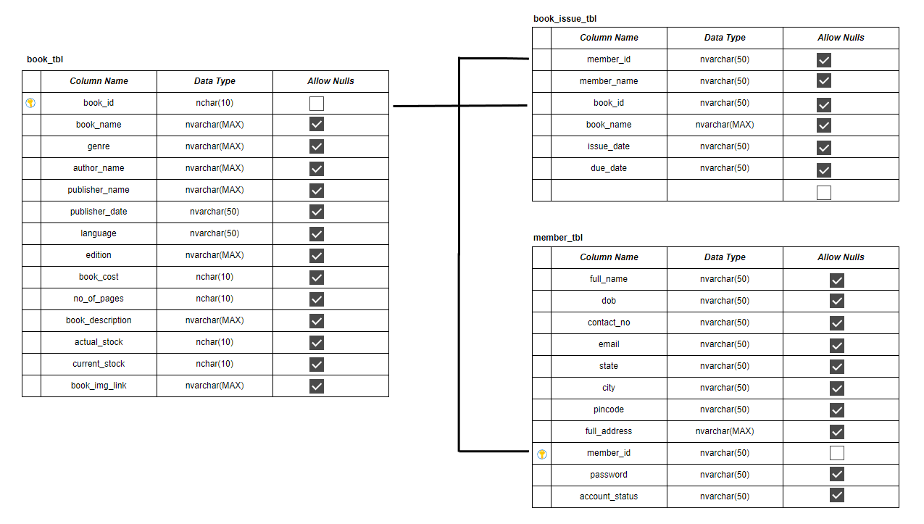

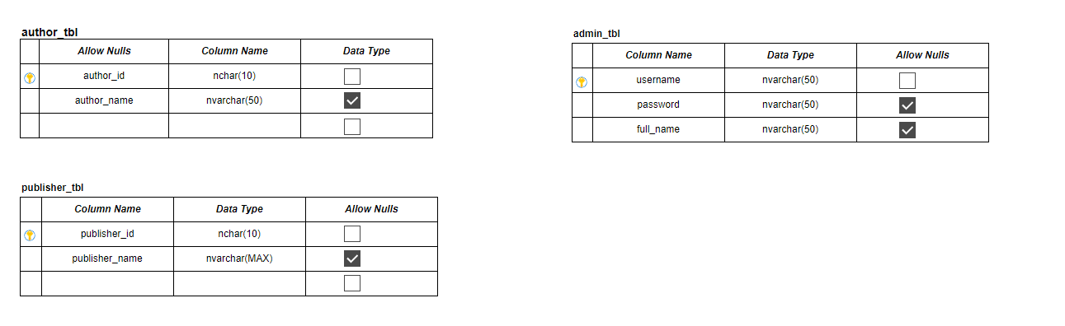

## Tables Structure

Table 1: author_tbl

|  |  |  |  |
| --- | --- | --- | --- |
| **Column Name** | **Data Type** | **Length** | **Nulls** |
| author_id | nchar | 10 | NO |
| author_name | nvarchar | 50 | YES |

Table 2: publisher_tbl

|  |  |  |  |
| --- | --- | --- | --- |
| **Column Name** | **Data Type** | **Length** | **Nulls** |
| publisher_id | nchar | 10 | NO |
| publisher_name | nvarchar | MAX | YES |

Table 3: member_tbl

|  |  |  |  |
| --- | --- | --- | --- |
| **Column Name** | **Data Type** | **Length** | **Nulls** |
| full_name | nvarchar | 50 | YES |
| dob | nvarchar | 50 | YES |
| contact_no | nvarchar | 50 | YES |
| email | nvarchar | 50 | YES |
| state | nvarchar | 50 | YES |
| city | nvarchar | 50 | YES |
| pincode | nvarchar | 50 | YES |
| full_address | nvarchar | MAX | YES |
| member_id | nvarchar | 50 | NO |
| password | nvarchar | 50 | YES |
| account_status | nvarchar | 50 | YES |

Table 4: admin_tbl

|  |  |  |  |
| --- | --- | --- | --- |
| **Column Name** | **Data Type** | **Length** | **Nulls** |
| username | nvarchar | 50 | NO |
| password | nvarchar | 50 | YES |
| full_name | nvarchar | 50 | YES |

Table 5: book_tbl

|  |  |  |  |
| --- | --- | --- | --- |
| **Column Name** | **Data Type** | **Length** | **Nulls** |
| book_id | nchar | 10 | NO |
| book_name | nvarchar | MAX | YES |
| genre | nvarchar | MAX | YES |
| author_name | nvarchar | MAX | YES |
| publisher_name | nvarchar | MAX | YES |
| publish_date | nvarchar | 50 | YES |
| language | nvarchar | 50 | YES |
| edition | nvarchar | MAX | YES |
| book_cost | nchar | 10 | YES |
| no_of_pages | nchar | 10 | YES |
| book_description | nvarchar | MAX | YES |
| actual_stock | nchar | 10 | YES |
| current_stock | nchar | 10 | YES |
| book_img_link | nvarchar | MAX | YES |

Table 6: book_issue_tbl

|  |  |  |  |
| --- | --- | --- | --- |
| **Column Name** | **Data Type** | **Length** | **Nulls** |
| member_id | nvarchar | 50 | YES |
| member_name | nvarchar | 50 | YES |
| book_id | nvarchar | 50 | YES |
| book_name | nvarchar | MAX | YES |
| issue_date | nvarchar | 50 | YES |
| due_date | nvarchar | 50 | YES |

# Appendices

## Glossary

|  |  |
| --- | --- |
| **Acronyms** | **Definitions** |
| ASP | Active Server Pages |
| SQL | Structured Query Language |
| MSSQL | Microsoft Structured Query Language |
| UI | User Interface |
| ETC | Etcetera |

# Terms & Conditions

***Disclaimer: Please do not circulate or distribute this document outside of Cognizant Network, We have a Zero Tolerance Policy. Kindly adhere to 100% Compliance at all times.***

# Change Log

*Please note that this table needs to be maintained even if a Configuration Management tool is used.*

|  |  |  |  |  |
| --- | --- | --- | --- | --- |
| **Version Number** | **Changes made** | | | |
| V<n.n> | *<If the change details are not explicitly documented in the table below, reference should be provided here>* | | | |
| Page no | Changed by | Effective date | Changes affected |
|  |  |  |  |
|  |  |  |  |
|  |  |  |  |
|  |  |  |  |